

**BAN444**

Digital Identity Management: Technology and Applications

Spring Semester 2025

**Paper Title**

Author 1, Author 1 Student ID, author1@nhh.no

Author 2

Author 3

Date: December 17, 2024

Summary

A short summary of the essay (max. 200 words). Lorem ipsum dolor sit amet, consectetuer adipiscing elit. Ut purus elit, vestibulum ut, placerat ac, adipiscing vitae, felis. Curabitur dictum gravida mauris. Nam arcu libero, nonummy eget, consectetuer id, vulputate a, magna. Donec vehicula augue eu neque. Pellentesque habitant morbi tristique senectus et netus et malesuada fames ac turpis egestas. Mauris ut leo. Cras viverra metus rhoncus sem. Nulla et lectus vestibulum urna fringilla ultrices. Phasellus eu tellus sit amet tortor gravida placerat. Integer sapien est, iaculis in, pretium quis, viverra ac, nunc. Praesent eget sem vel leo ultrices bibendum. Aenean faucibus. Morbi dolor nulla, malesuada eu, pulvinar at, mollis ac, nulla. Curabitur auctor semper nulla. Donec varius orci eget risus. Duis nibh mi, congue eu, accumsan eleifend, sagittis quis, diam. Duis eget orci sit amet orci dignissim rutrum.

Table of Contents

1 Introduction 1

2 Background 2

2.1 Useful commands when writing the paper with LATEX 2

2.2 Including figures 2

2.3 Including tables 4

Optional: Acronmys

ZKP zero-knowledge proof

Optional: List of Figures and List of Tables

# Introduction

Permissionless blockchains go back to the Bitcoin whitepaper and implementation (Nakamoto, 2008). According to Fridgen et al. (2018), blockchain technology is great for cross-organizational processes. Yet blockchain also comes with challenges (Fridgen et al., 2018; Roth et al., 2022).

Some new paragraph ...Nam dui ligula, fringilla a, euismod sodales, sollicitudin vel, wisi. Morbi auctor lorem non justo. Nam lacus libero, pretium at, lobortis vitae, ultricies et, tellus. Donec aliquet, tortor sed accumsan bibendum, erat ligula aliquet magna, vitae ornare odio metus a mi. Morbi ac orci et nisl hendrerit mollis. Suspendisse ut massa. Cras nec ante. Pellentesque a nulla. Cum sociis natoque penatibus et magnis dis parturient montes, nascetur ridiculus mus. Aliquam tincidunt urna. Nulla ullamcorper vestibulum turpis. Pellentesque cursus luctus mauris.

Another paragraph .... Nulla malesuada porttitor diam. Donec felis erat, congue non, volutpat at, tincidunt tristique, libero. Vivamus viverra fermentum felis. Donec nonummy pellentesque ante. Phasellus adipiscing semper elit. Proin fermentum massa ac quam. Sed diam turpis, molestie vitae, placerat a, molestie nec, leo. Maecenas lacinia. Nam ipsum ligula, eleifend at, accumsan nec, suscipit a, ipsum. Morbi blandit ligula feugiat magna. Nunc eleifend consequat lorem. Sed lacinia nulla vitae enim. Pellentesque tincidunt purus vel magna. Integer non enim. Praesent euismod nunc eu purus. Donec bibendum quam in tellus. Nullam cursus pulvinar lectus. Donec et mi. Nam vulputate metus eu enim. Vestibulum pellentesque felis eu massa.



Figure 1: NHH Logo.

# Background

As highlighted in the Introduction Section / Section 1, ...

## Useful commands when writing the paper with LATEX

For a template, visit <https://www.overleaf.com/read/xwhrcxycrsmh> or see the zip file.

If you write the paper with MS Word, consider using reference management software that provides a Word plugin, e.g., Citavi. For LaTeX, one can use Biblatex directly or use tools like Zotero.

Zero-knowledge proofs (ZKPs) are important. A ZKP is defined via ... We use ZKPs in ...

## Including figures

Figures can be cropped conveniently. One can link to them conveniently; see Figure 3. Vector images are preferred. One good approach is making the Figures in Powerpoint, exporting them as pdf (multiple pages), uploading them as Figures.pdf and then use \includegraphics[page=1, width=..., trim=..., clip]{Figures.pdf}. This avoids the need to upload many individual figures. For instance, I uploaded the File Zero-Knowledge Proofs.pdf and will include the first and third page in the following two figures.



**Bonus topic:**

**Zero**

**-**

**Knowledge Proofs**

Figure 2: First page of the presentation.



45

**Zero**

**-**

**knowledge**

**proofs**

“t

hose proofs that convey no additional knowledge other than the correctness of the proposition in question

“

1985)

GMR,

(



Most

popular

short

/

efficient

ZKPs:

•

zk

-

SNARKs

(

**succinct**

non

-

interactive

arguments

of

knowledge

)

•

zk

-

STARKs

(

**scalable**

transparent

arguments

of

knowledge

)



**Examples**

**:**

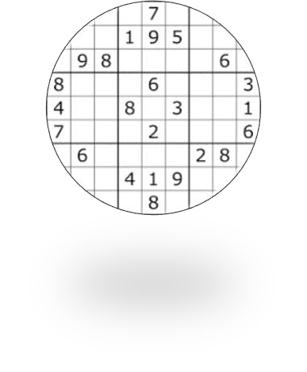

Proof

of

knowledge

of

a

solution

to

a

given

Sudoku puzzle,

without

revealing

any

information

that

would

make

it

easier

for

the

verifier

to

solve

it.

Proof

of

knowledge

of

a private

key

(

associated

with

a

public

key

)

,

without

leaking

information

that

would

allow

or

ease

reconstructing

the

secret

key

.

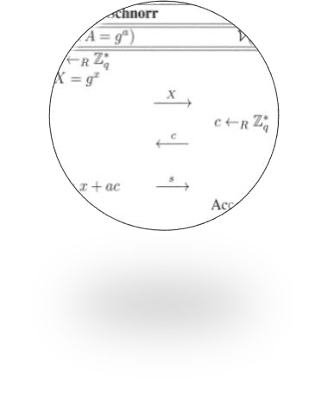

In

general

, (

succinct

ZKPs

)

certify

the

correct

execution

of

an

algorithm

with

a

(

very

short

)

cryptographic

attestation

while

revealing

only

explicitly

selected

inputs

,

intermediary

results

, and

outputs

.



Figure 3: Third page of the presentation.

## Including tables

Use [H] to place the table at exactly this place. Use [h] to place it at this place if suitable. Most of the time, [!tb] will be better, then it is placed at the top or bottom of a page nearby. Refer to table via Table 1.

|  |  |
| --- | --- |
| A | B |
| C | D |

Table 1: My table caption.

References

Fridgen, G., Radszuwill, S., Urbach, N., & Utz, L. (2018). Cross-organizational workflow management using blockchain technology – towards applicability, auditability, and automation. *Proceedings of the 51st Hawaii International Conference on System Sciences*, 3507–3516. <https://doi.org/10.24251/hicss.2018.444>

Nakamoto, S. (2008). Bitcoin: A peer-to-peer electronic cash system. Retrieved April 17, 2023, from <https://bitcoin.org/bitcoin.pdf>

Roth, T., Utz, M., Baumgarte, F., Rieger, A., Sedlmeir, J., & Struker, J. (2022). Electricity powered¨ by blockchain: A review with a European perspective. *Applied Energy*. [https://doi.org/10.](https://doi.org/10.1016/j.apenergy.2022.119799)

[1016/j.apenergy.2022.119799](https://doi.org/10.1016/j.apenergy.2022.119799)